- Lab Title: Virtual Lab Environment Setup, Connectivity Verification & Web Proxy Configuration
- Assignment Title: Virtual Lab Environment Setup, Connectivity Verification & Web Proxy Configuration
- Student Name: Bashir Adam
- Student ID: 2025/FWSD/11509
- Course Name: BVWS102 – OWASP Top 10 Vulnerabilities & Exploitation Techniques
- Instructor Name: Aminu Ibrahim Jalo
- Date of Submission: 21 DEC, 2025
- Version: Version 1.1.0

LAB OVERVIEW/OBJECTIVE
1. Objective

The objective of this lab is to assess the student’s ability to correctly set up a basic offensive security lab environment, verify network connectivity between attacker and target machines, deploy vulnerable web applications, and configure Burp Suite Professional with browser proxy interception

2. Lab Environment Requirements

- Each student must use the following setup:
- Hypervisor: VMware Workstation or VirtualBox
- Attacker Machine: Kali Linux
- Target Machine: Metasploitable2
- Browser: Firefox (on Kali Linux)
- Proxy Tool: Burp Suite Professional
- Vulnerable Web App: DVWA or Mutillidae

Lab Tasks & Evidence Requirements

Task 1: Metasploitable Installation

After succefull installation of VirtualBox and downlode of the metasploitable2 from the ICDFA platform

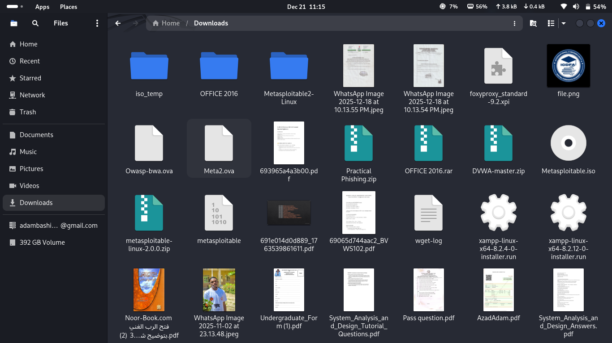
I move direct to import the file in the VirtualBox

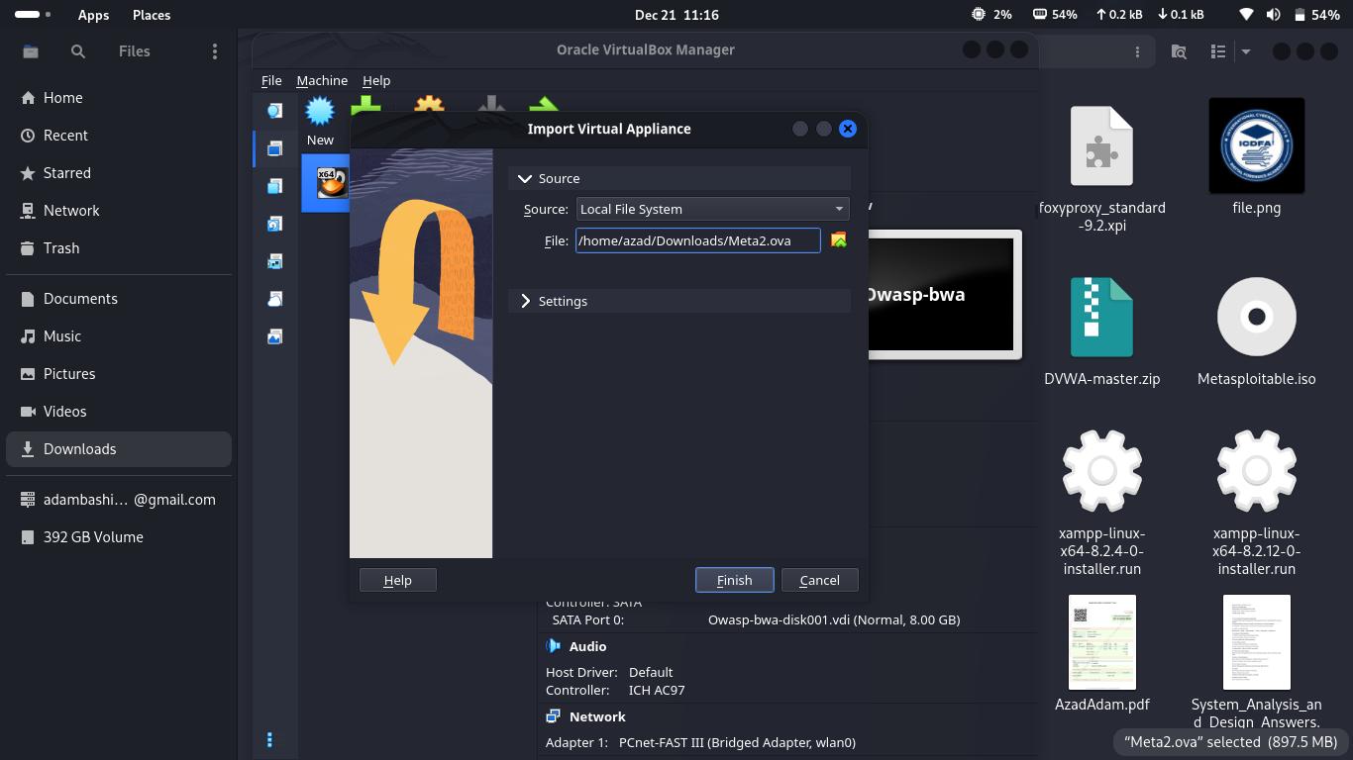

the process of importing

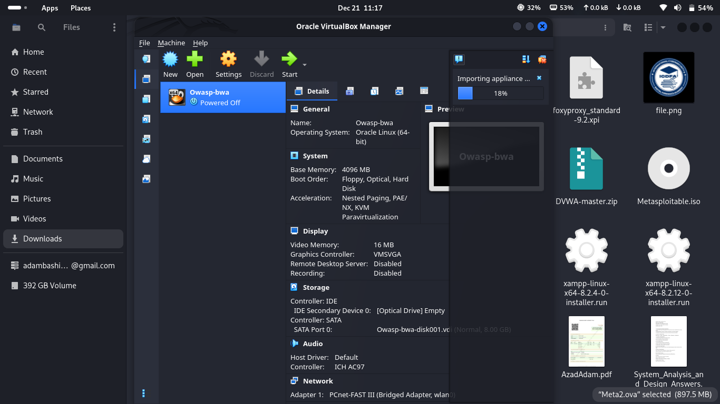
importing succefull

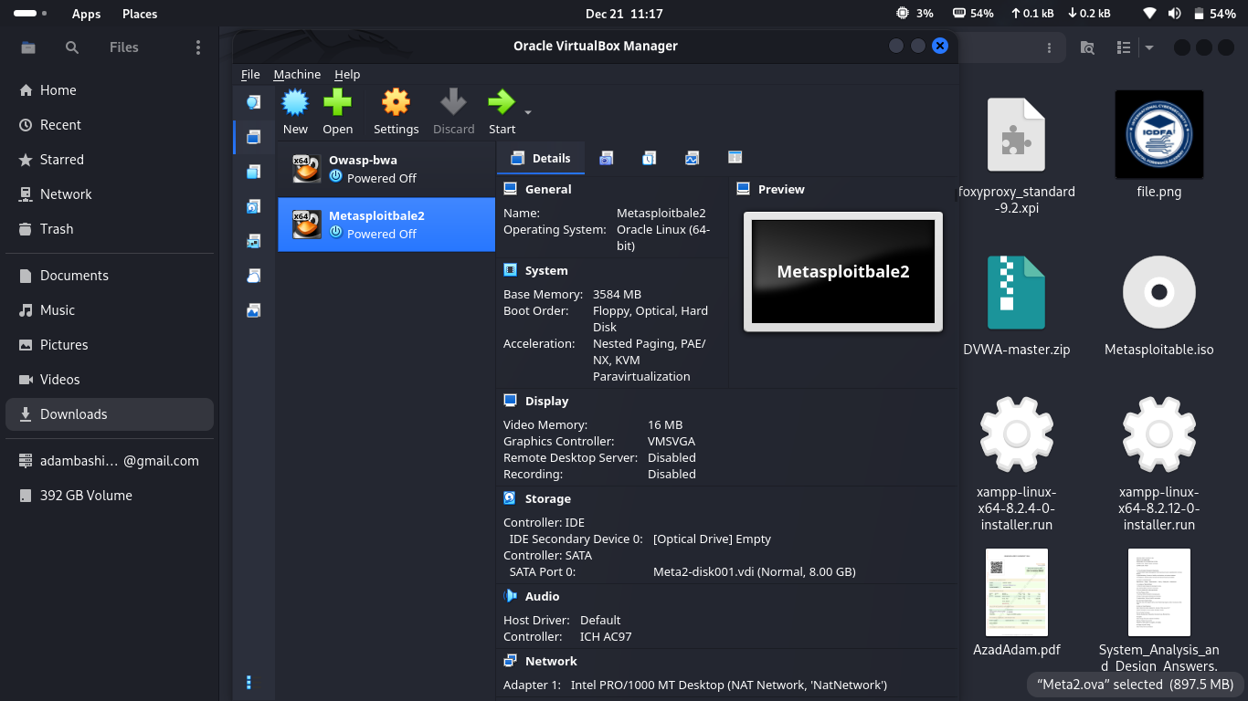

I run a quick test on the metasploitable2 and it works succefull

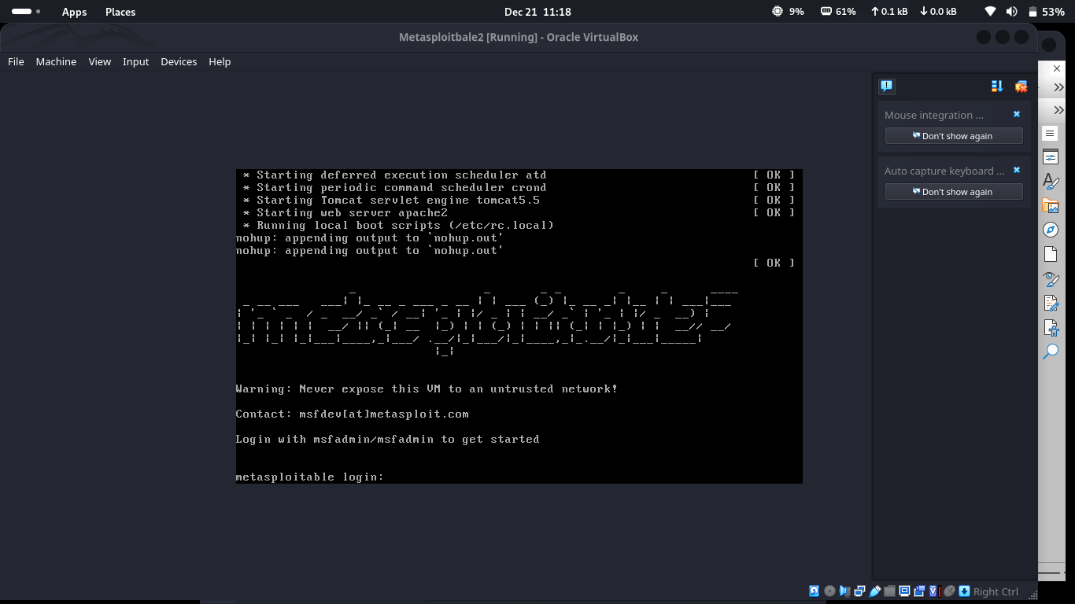
I chance the network setting to Bridged Adapter becouse the defult setting does not support Host Only Adapter due to the reson that am using kali linux as my main operating system

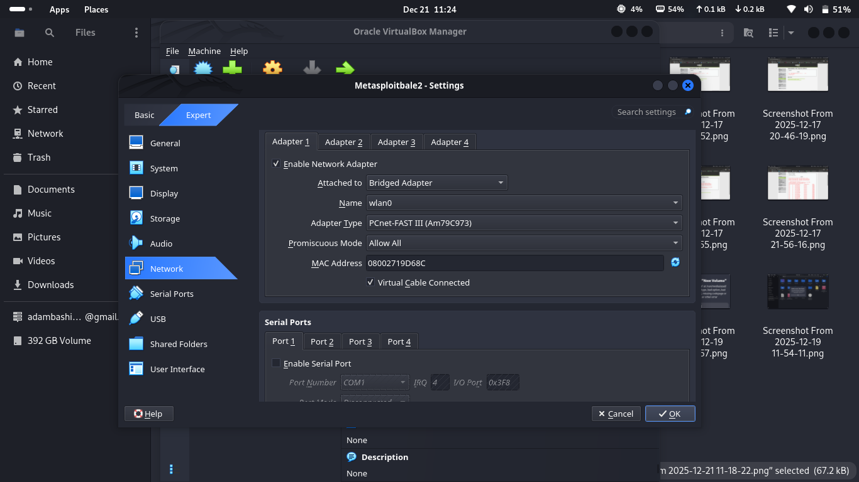

the metasploitable2 is set succefully and the IP is ok

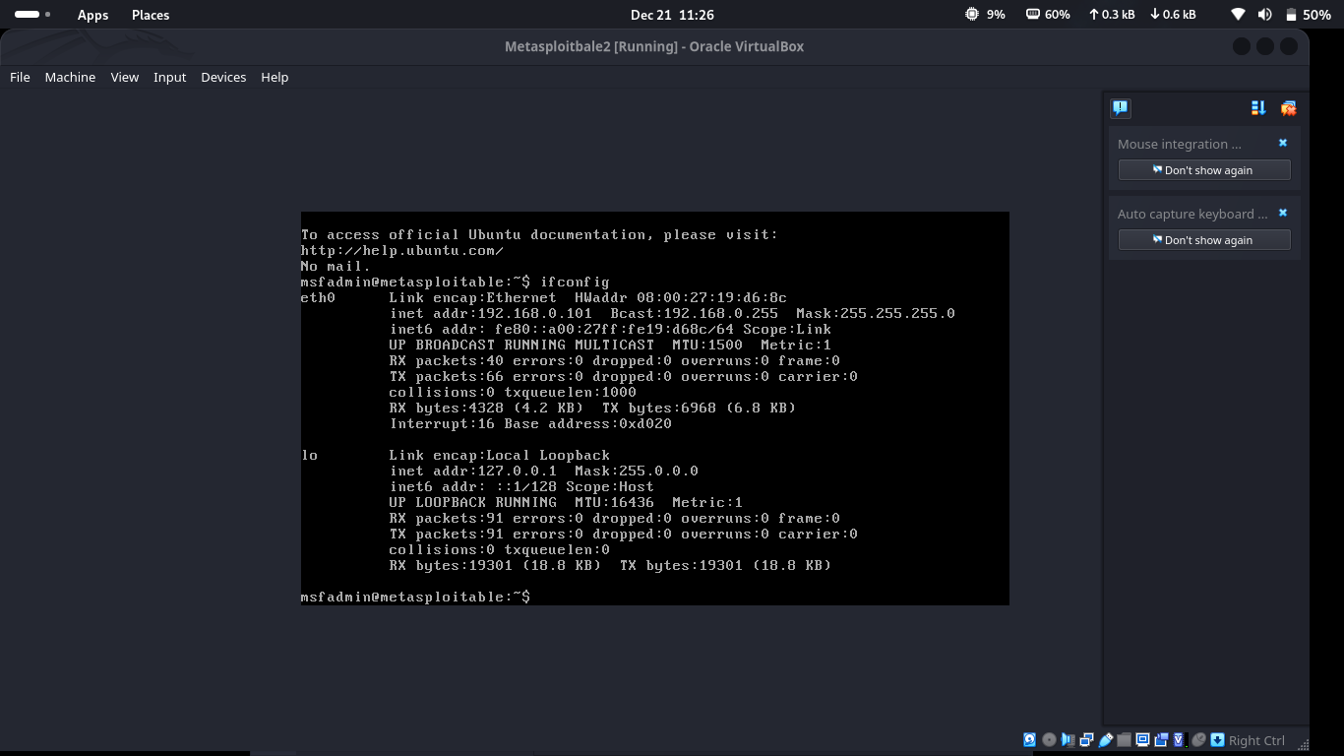

Task 2: Network Connectivity Verification

the corrent IP Address runing in my metasploitable2 is 192.168.0.101



From my terminal I ping the IP Address using the command ping 192.168.0.101

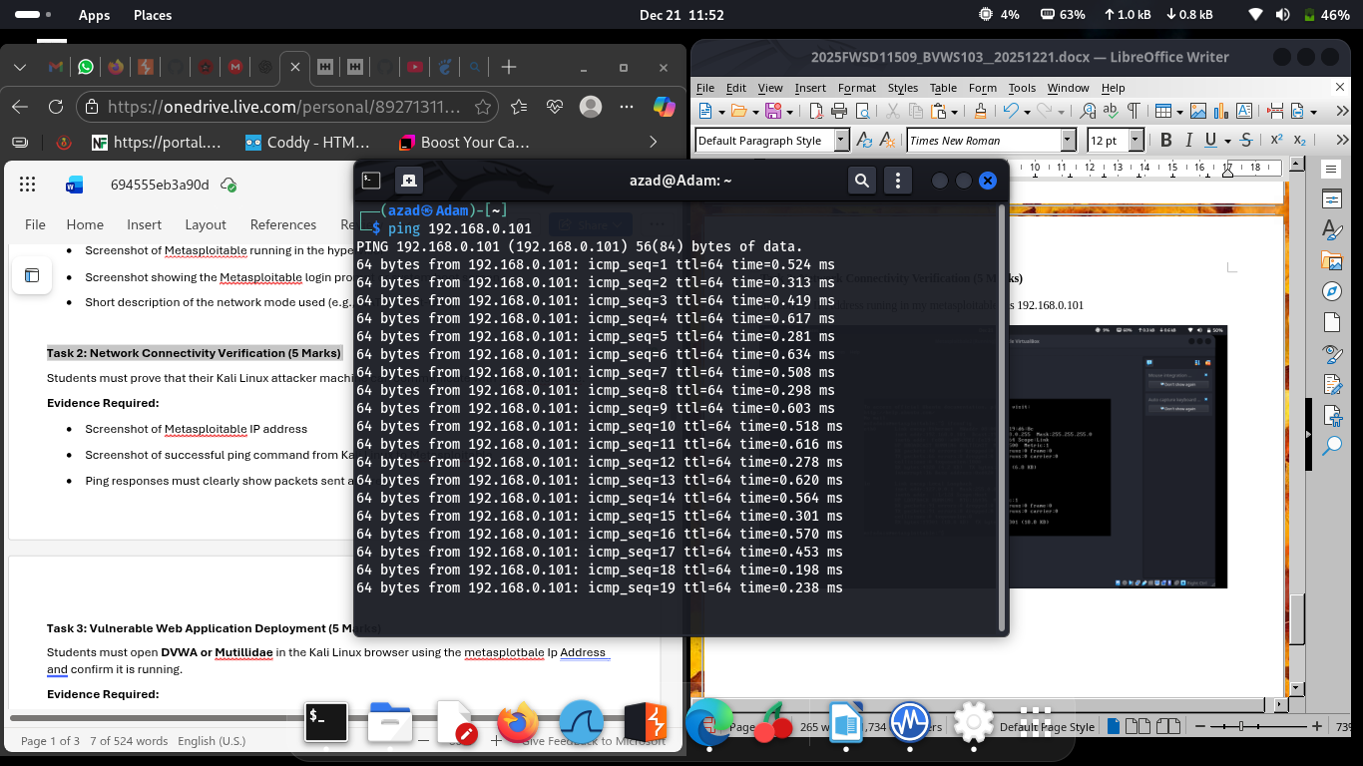

A succefull Pinging responses showing packets sent and received

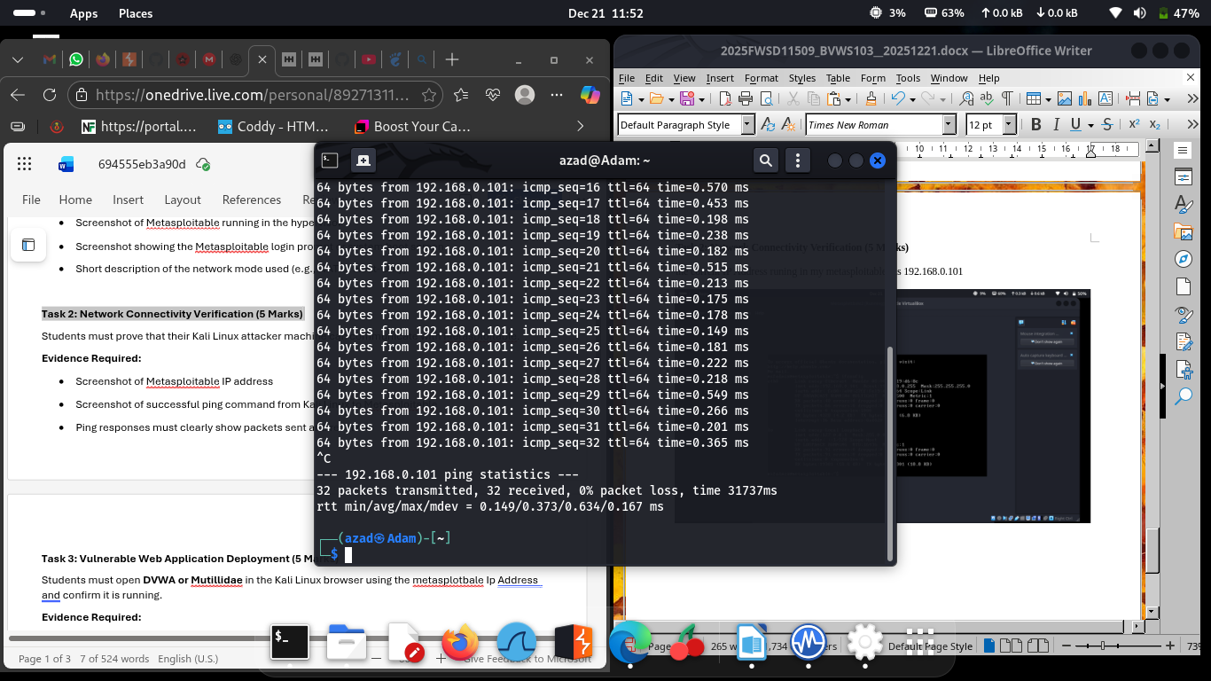

Task 3: Vulnerable Web Application Deployment (5 Marks)

this is home page of my metasploitable2 and the options of volnarable website it containe

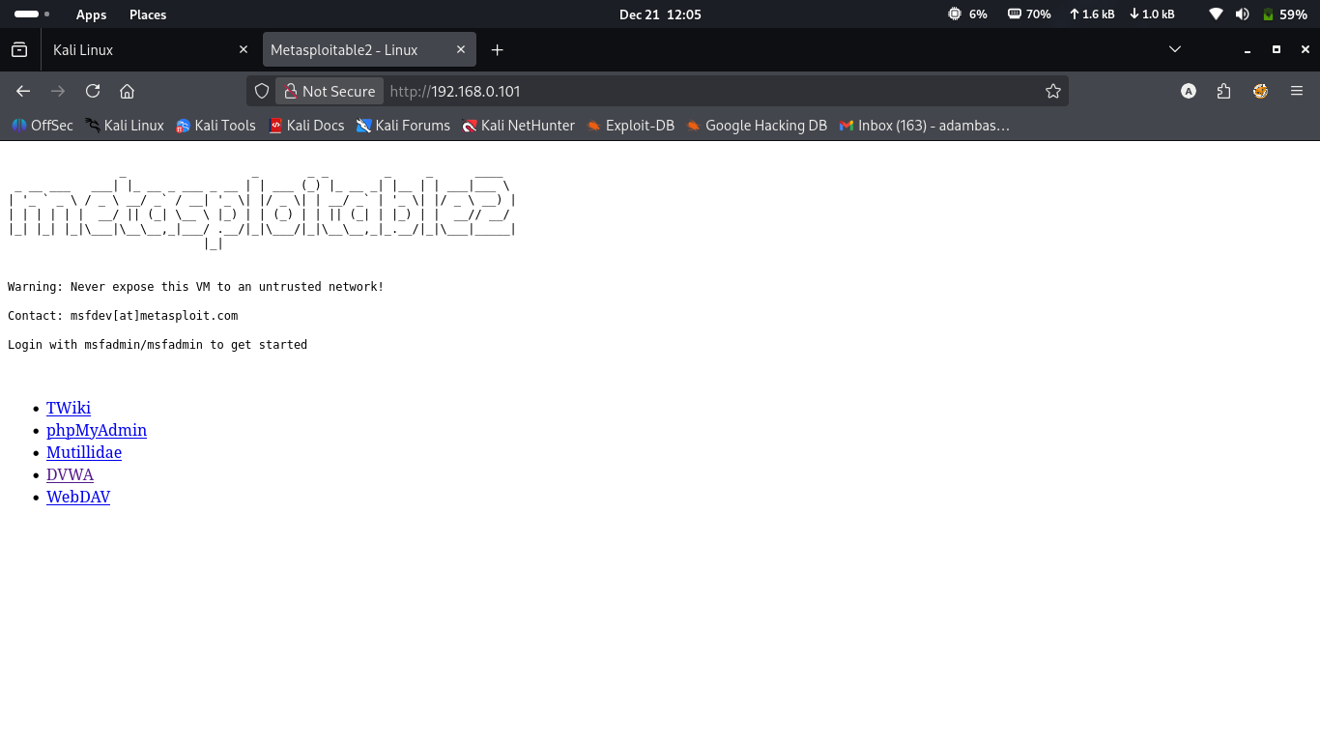
DVWA is a deliberately insecure web application written in PHP & MySQL/MariaDB, used for learning and practicing web application security. It helps students and security beginners in cybersecurity to practice common web vulnerabilities legally in a safe lab environment.
And it helps to Learn how attacks work, Understand why insecure code is dangerous, Practice secure coding and Prepare for CTFs, exams, and real pentesting

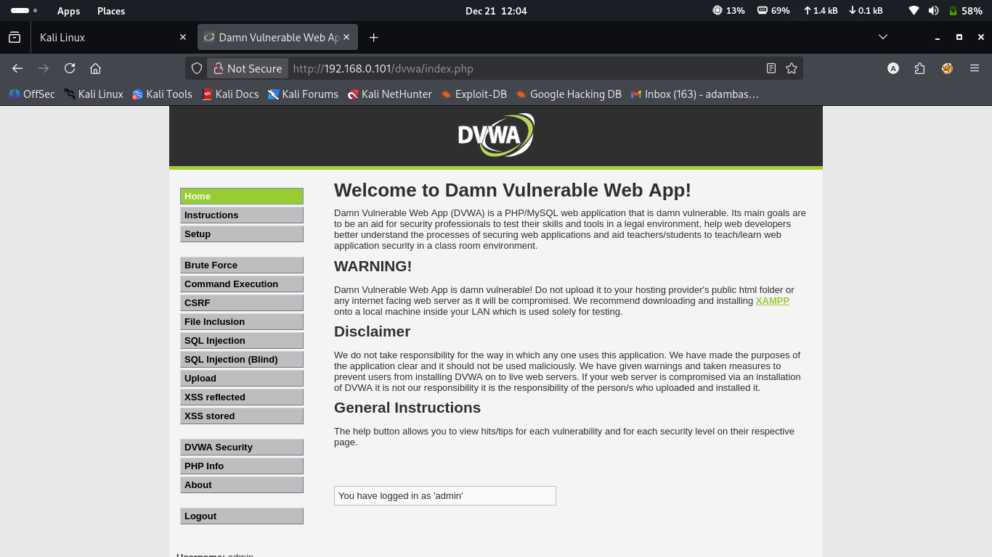
the URL bar showing the application address
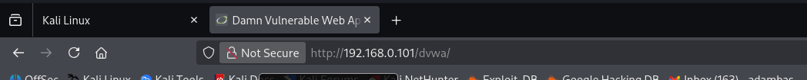

Task 4: Burp Suite Professional Installation & Licensing (7 Marks)

I firest of all go to the ICDFA/Burpsuite-professional site and clck on the code to copy the URL

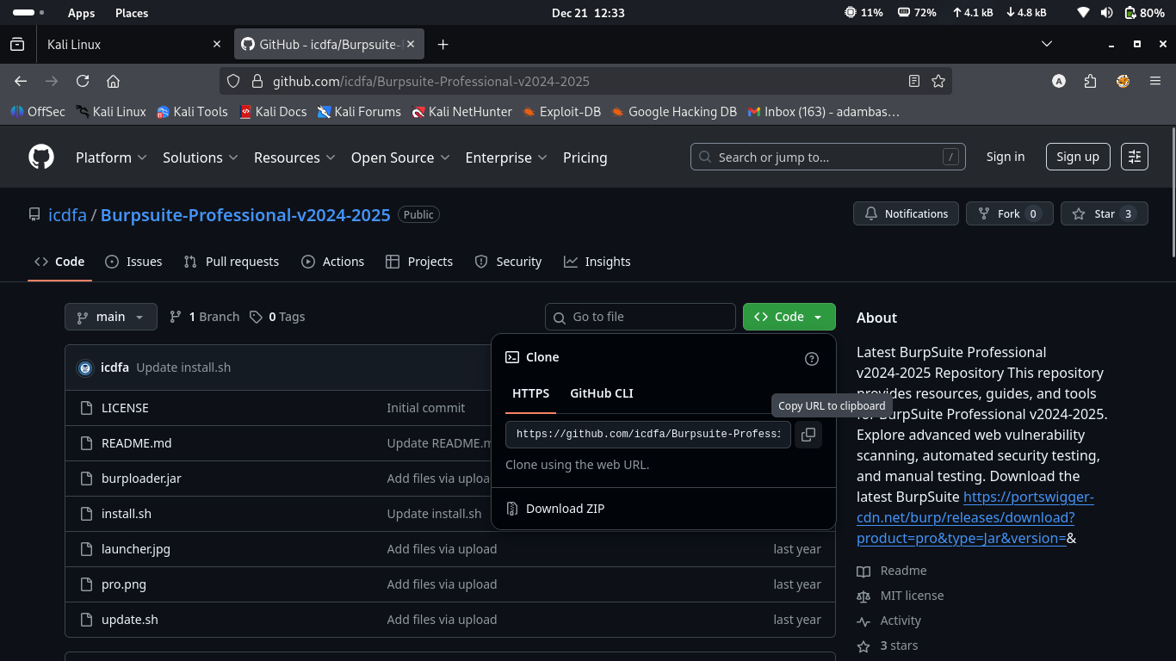
then move to our terminal to clone it using git and the go to the Burp Suite Professional dashboard to downlode the java file of the it

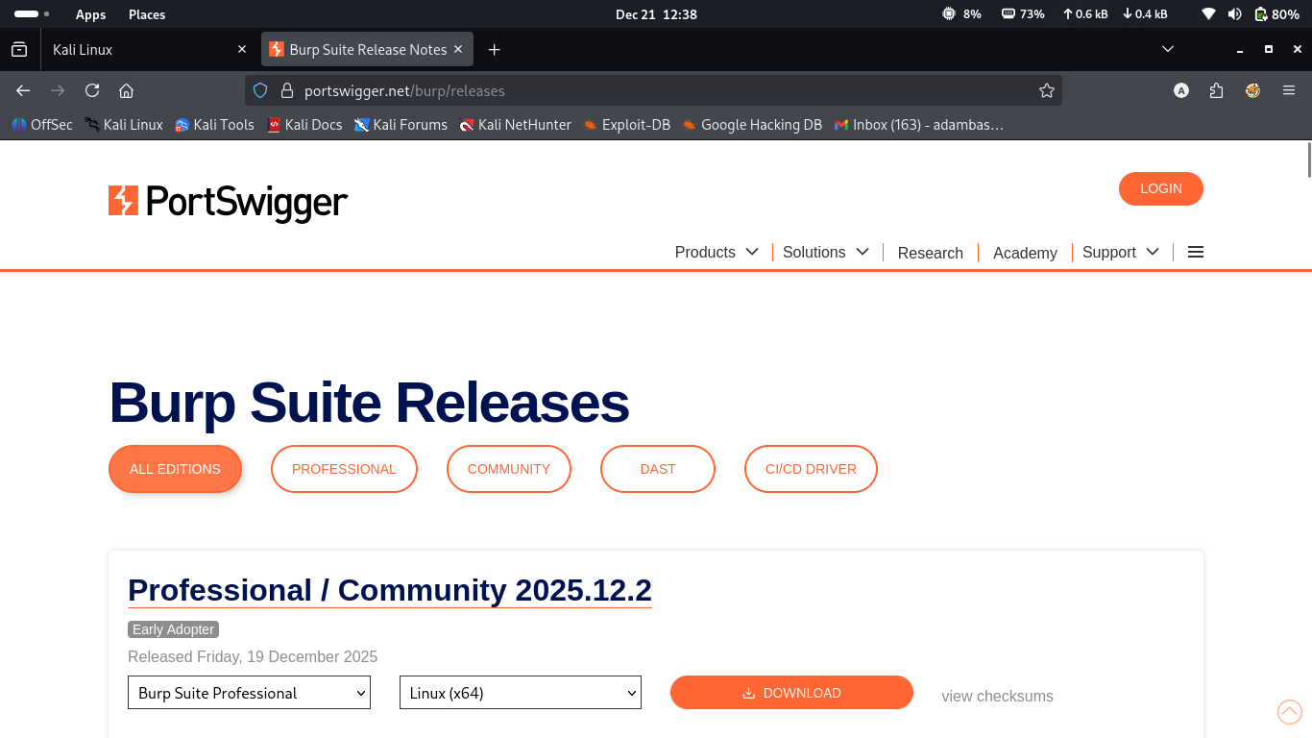

After finishing downloding the file the you copy the file and paste it in the cloned directory of the burpsuit

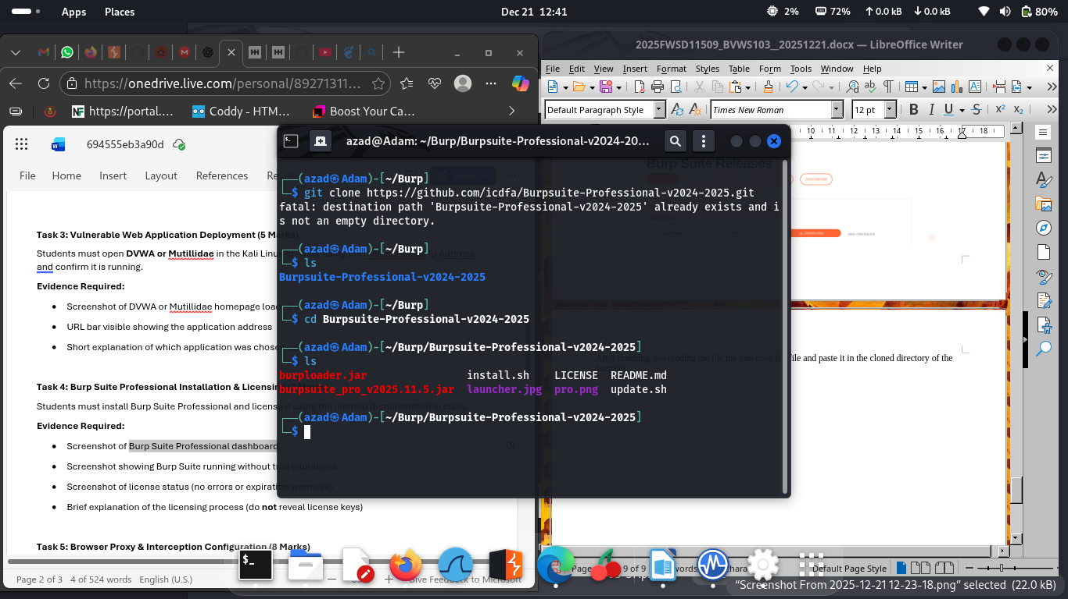
then you use the burploader.jar to open the burpsuite_pro_v2025.11.5.jar using the command
java -jar butploader.jar

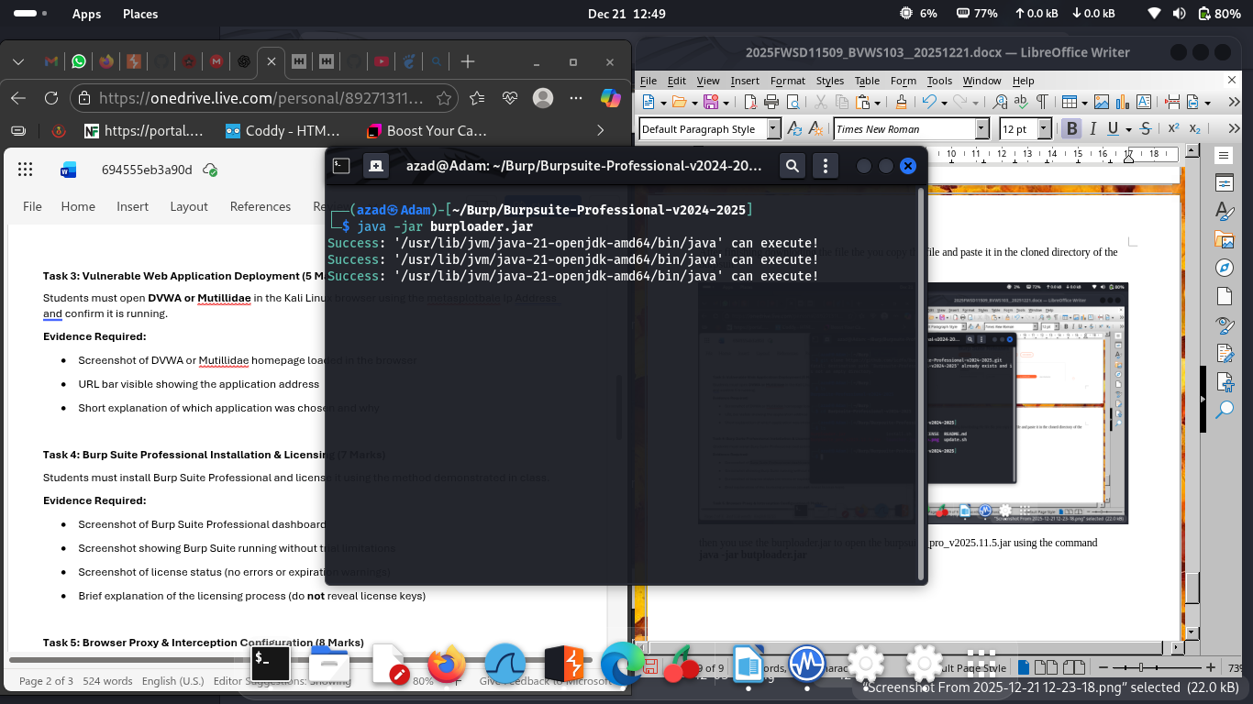

The burploader setting up the license

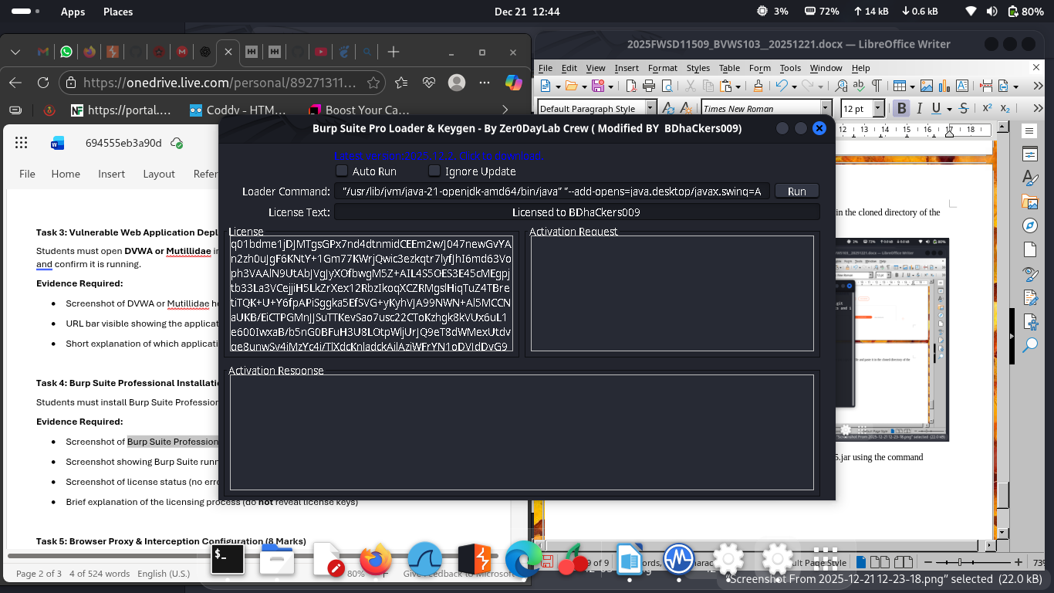
After all process of licensing the BurpSuite is stating perfectly

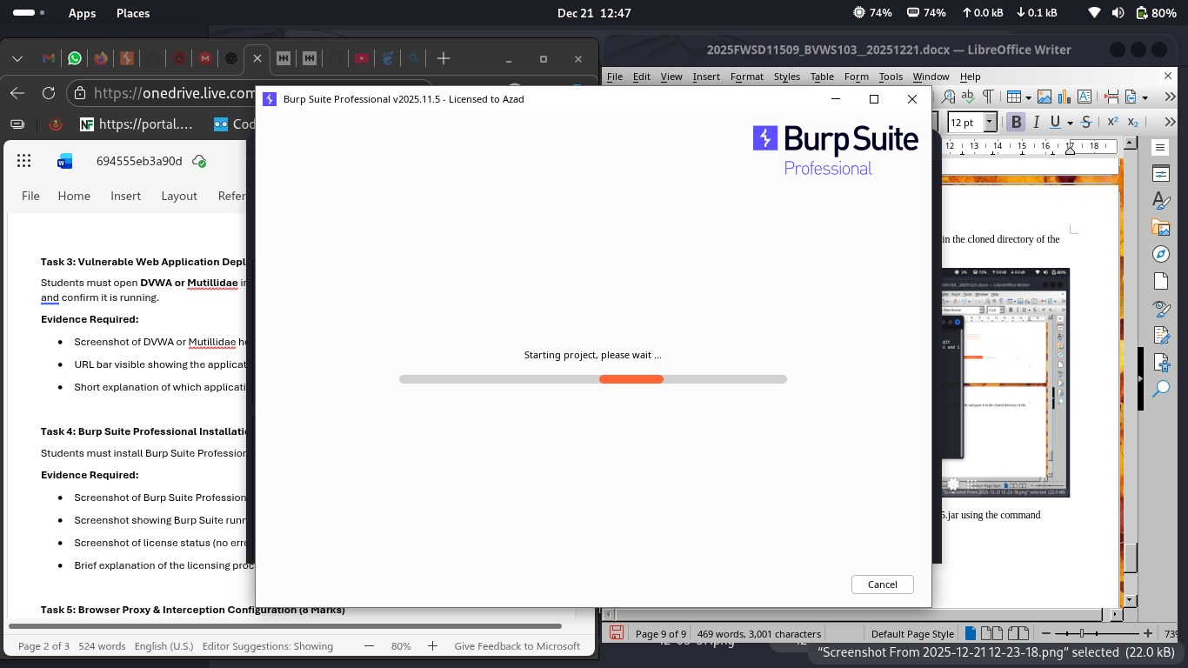

the license status showing no errors or expiration warnings

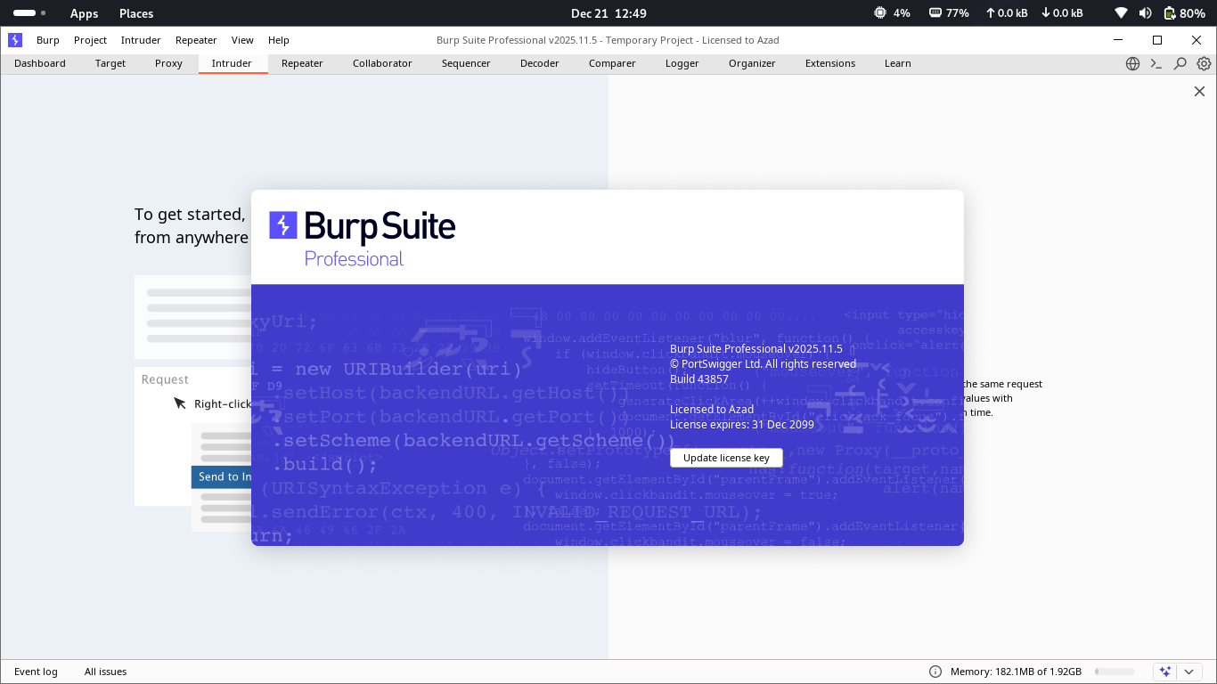

My burpSuit darshbord

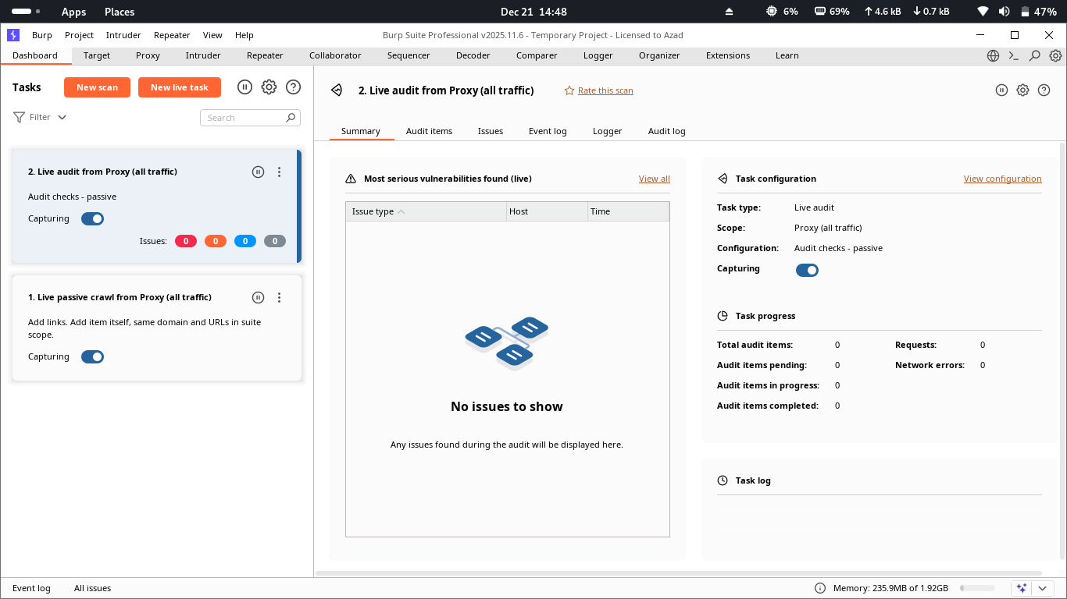

Task 5: Browser Proxy & Interception Configuration (8 Marks)

from this side we Add the extension of our FoxyProxy to the Browser

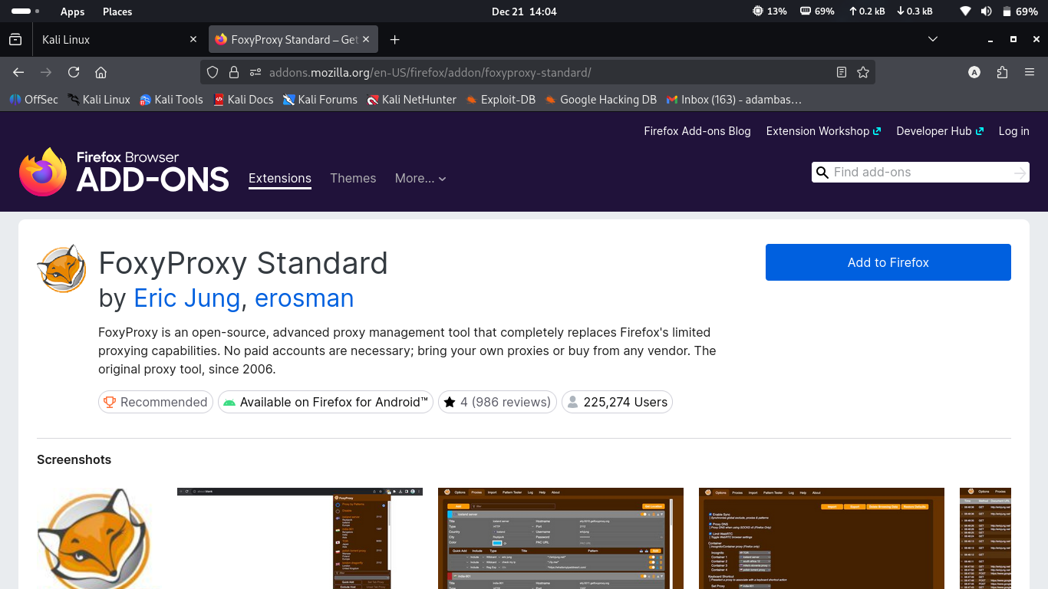

FoxyProxy was added succefully

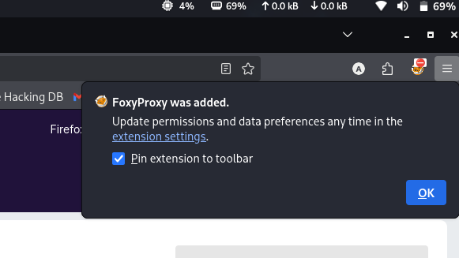

setting up my local host connectivity using the ip 127.0.0.1 and port 8080

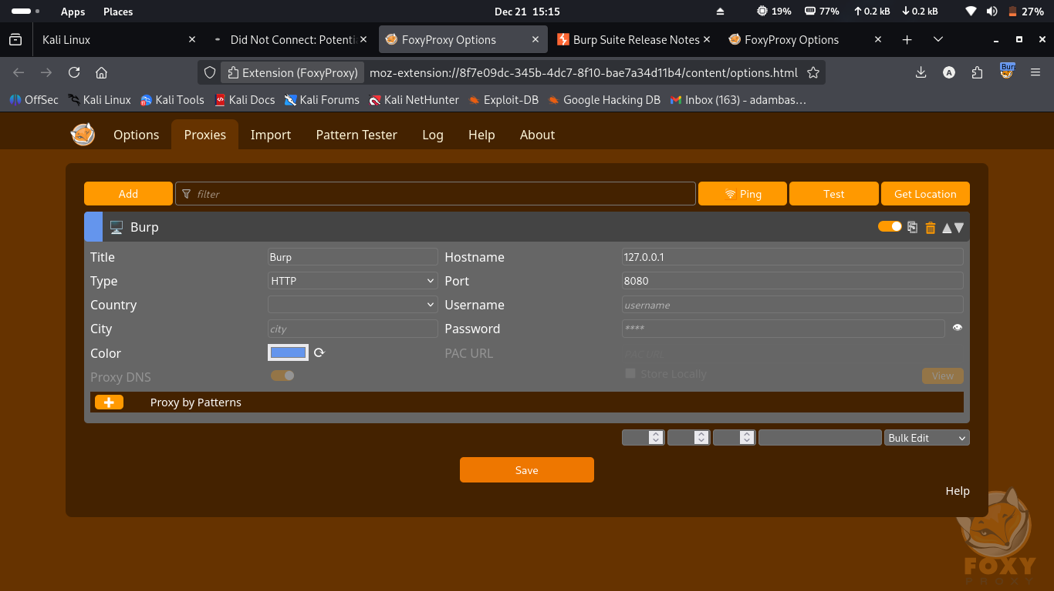

example of request send from the browser to the BurpSuite

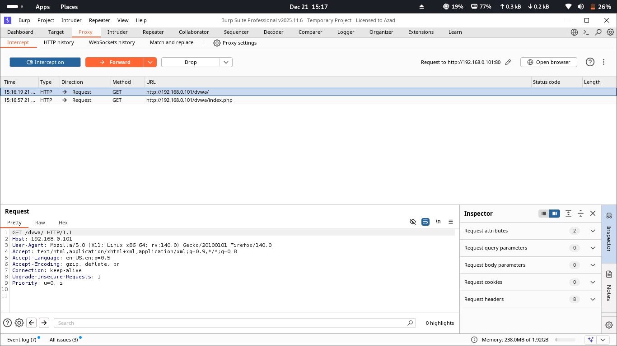

the icon below shows that burp is on and redy to accept reqest

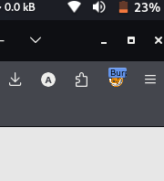

Conclusion

At the end of this lab Assignment I was able to:
- Build a functional penetration testing lab
- Verify attacker-target connectivity
- Deploy vulnerable web applications
- Configure professional web proxy tools
- Intercept and analyze web traffic

